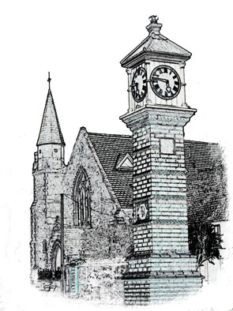

Usk Dental Practice

Date : 1 July 2020

Equality and diversity policy for patients

Our vision is for Usk Dental Practice to be a successful, caring and welcoming place for patients to receive their dental care and advice. We want to create a supportive and inclusive environment where our staff can reach their full potential and care is provided in partnership with our patients, without prejudice or discrimination. We are committed to creating a culture of respect and understand and recognise the value of individual diversity. This policy helps us to achieve this vision and avoid discrimination in any form ensuring that we treat people fairly and equally.

Non-discrimination rights are protected by anti-discrimination legislation including the Equality Act 2010.

The aim of this policy is to remove any potential discrimination in the way that people with protected characteristics are cared for by the practice. This means that we will not treat you less favourably because of your age, a disability, gender reassignment, marriage and civil partnership, pregnancy and maternity, race, religion or belief, sex and sexual orientation.

We will develop and support equality and diversity by tackling oral health inequalities through positive promotion and care. This means that we will

- Providing you with information in languages other than English, where required
- Having translation services available if you need this
- Taking reasonable steps to ensure that you can access our services if you have a disability
- Ensuring that the care we provide meets your needs
- Ensuring that we work closely with other medical and social services involved in your care.

We will monitor the effectiveness of this policy and its impact on other relevant policies and practice.

Concerns and comments
If you believe you have been treated in any way contrary to this policy or you have any comments on how we can ensure that it works better, please contact Miles Gladson at the practice. We will investigate your concerns and, where appropriate, take necessary action.

Signed

Date 1 July 2020

Review date: 1 year.

